**Day-3 Assignments 1,2&3**

**Assignment 1:**

Creating an infographic for Test-Driven Development (TDD) involves visualizing the key steps and benefits of the process. Here’s an outline for your TDD infographic:

Infographic

1. **Title: Test-Driven Development (TDD) Process.**

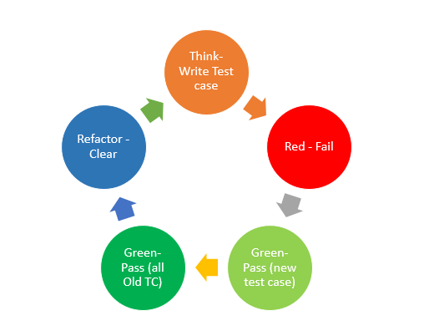

**2. TDD Process Steps**

* Step 1: Write a Test

-> Write a test for a small piece of functionality that is yet to be implemented.

* + Step 2: Run the Test

-> Run the test and watch it fail since the functionality is not yet implemented.

* + Step 3: Write the Code

-> Write the minimal code necessary to make the test pass.

* + Step 4: Run All Tests

-> Run all tests to ensure the new code doesn’t break existing functionality.

* + Step 5: Refactor the Code

-> Refactor the code to improve its structure and readability without changing its behaviour.

* + Step 6: Repeat

-> Repeat the cycle for the next piece of functionality.

**3. Benefits of TDD**

- Bug Reduction: Early bug detection and fixing reduces the number of bugs in the final product.

-Software Reliability: Continuous testing ensures the software works as expected, enhancing reliability.

-Improved Code Quality: Encourages better design and coding practices through refactoring.

-Documentation: Tests serve as documentation, helping new developers understand the codebase.

-Faster Development: Reduces the need for debugging and extensive testing at the end of the development cycle.

**4. Conclusion**

**-** Emphasize how TDD leads to better software development practices and more reliable, maintainable code.

**Assignment 2:**

Produce a comparative infographic of TDD, BDD, and FDD methodologies. Illustrate their unique approaches, benefits, and suitability for different software development contexts. Use visuals to enhance understanding

Comparative Infographic: TDD vs. BDD vs. FDD

1. **Overview**

**TDD (Test-Driven Development)**

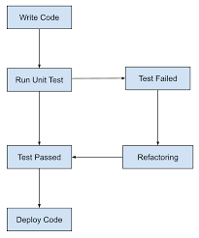

Approach: Write tests before writing code.

Cycle: Red-Green-Refactor.

Focus: Unit testing, code-centric.

**BDD (Behaviour-Driven Development)**

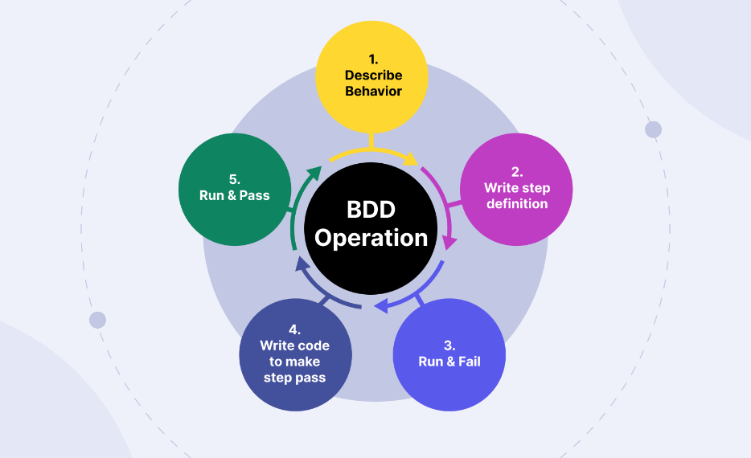

Approach: Define behaviour through examples.

Language: Uses natural language (Given-When-Then).

Focus: Collaboration between developers, testers, and business stakeholders.

**FDD (Feature-Driven Development)**

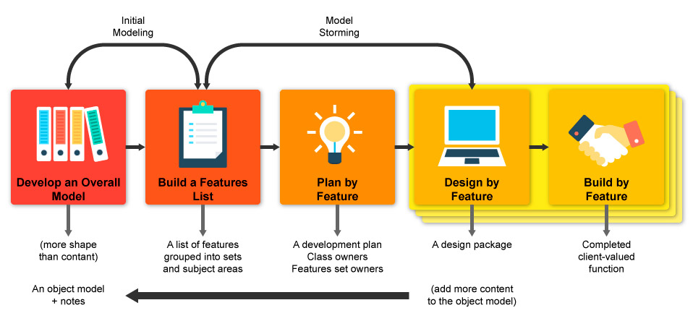

Approach: Iterative and incremental development by features.

Phases: Domain Object Modelling, Development by Feature.

Focus: Large-scale, team-based projects.

**2. Unique Approaches**

* TDD
  + Tests drive the development process.
  + Ensures code is testable and reliable from the start.
* BDD
  + Focuses on behaviours and interactions.
  + Enhances collaboration and understanding across teams.
* FDD
  + Features are developed in short iterations.
  + Emphasizes clear ownership and progress tracking.

**3. Benefits**

* TDD
  + Early detection of defects.
  + Improved code quality and design.
  + Faster feedback loop.
* BDD
  + Enhanced collaboration and communication.
  + Clearer understanding of requirements.
  + Reduced rework due to shared understanding.
* FDD
  + Structured approach to managing large projects.
  + Clear milestones and progress tracking.
  + Promotes productivity through feature completion.

**4. Suitability for Different Contexts**

* TDD
  + Ideal for projects requiring high code quality and maintainability.
  + Suitable for agile development environments.
* BDD
  + Best for projects with complex business requirements.
  + Useful in scenarios where collaboration between teams is crucial.
* FDD
  + Suited for large-scale projects with clearly defined features.
  + Effective in environments needing structured project management.

--------------------------------------------------------------------------------------------------------------------------

**Assignment 3:**

Write the Agile Principles

1.Customer Satisfaction.

2.Adapt to change request.

3.Frequent delivery.

4.Colloborations.

5.Working software.

6.Motivated team.

7.Face to Face interaction.

8.Sustainable development .

9.Simplicity.